CV task 2.1 report:

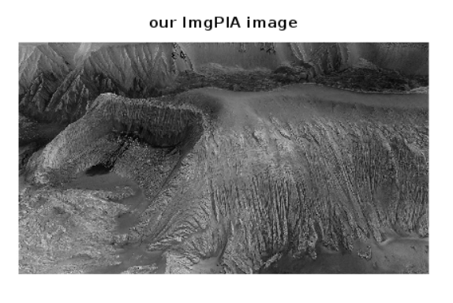

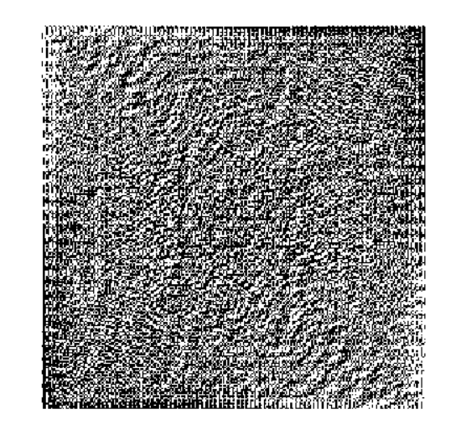

Figure: Transform of an image

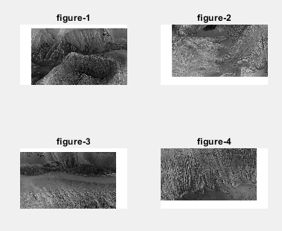

Figure: SEGMENTing our ImgPIA INTO four different SECTION

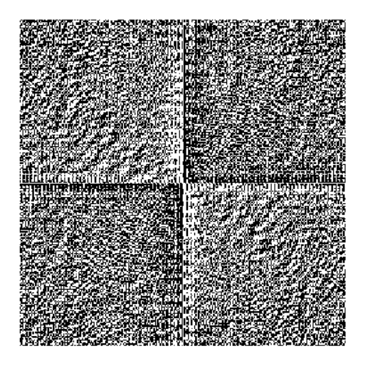

Figure: using discrete fourier transform function for four sections

NOW USING THE FOURIER with INVERSE fourier transform function

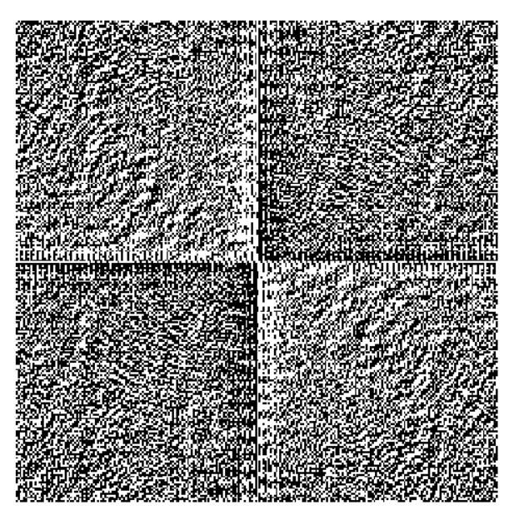

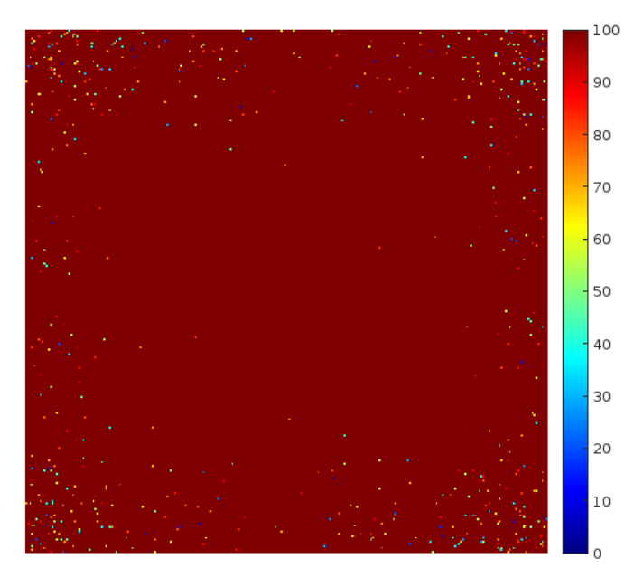

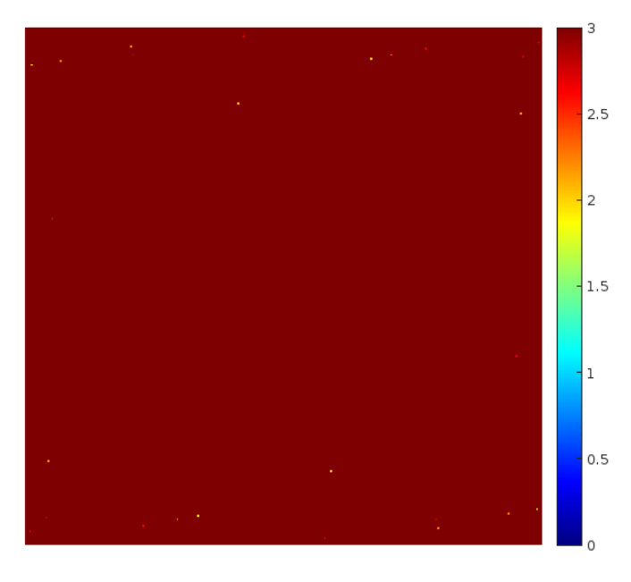

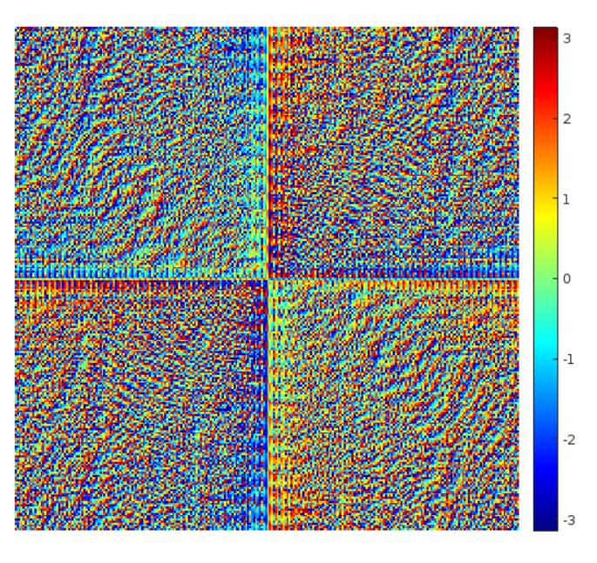

Fig: fourier transform func



Fig: inverse transform func

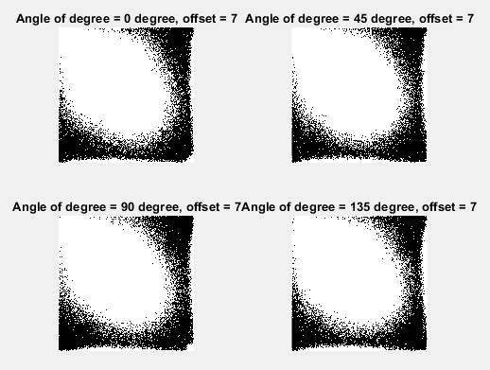

Figure: co-occurrence matrix for offset value 7 and four different degrees.

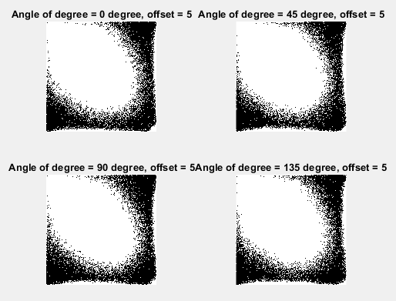

Figure: co-occurrence matrix for offset value 5 and four different degrees.

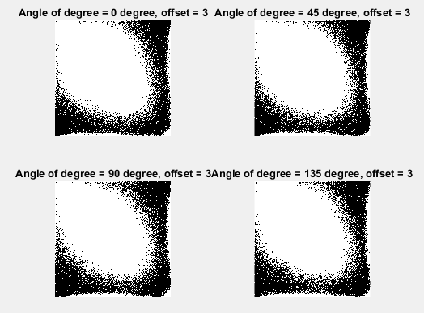

Figure: co-occurrence matrix for offset value 3 and four different degrees.

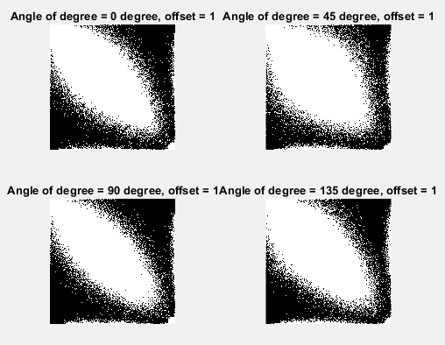

Figure: co-occurrence matrix for offset value 1 and four different degrees.

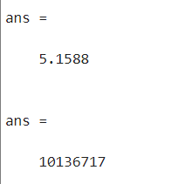

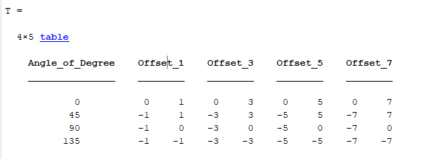

Plotting the values